
EN
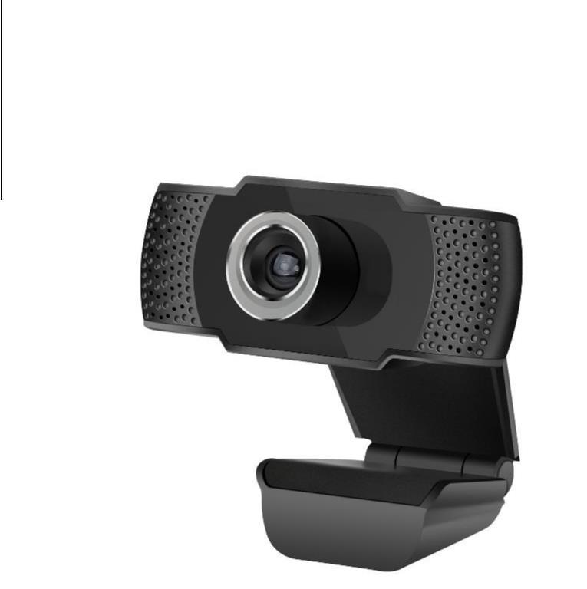

[USER´S GUIDE]

c-tech cam-07hd


1. IMPORTANT NOTICE

Thank you for purchasing our C-TECH product. To ensure that your product serves you as long as possible, please read this manual carefully.

  - Term of use of the product

- The product must always be used for its intended purpose, otherwise this may void the warranty

- The product is intended for household use, not for professional or industrial use.

- Unless otherwise specified, the product must not be used outdoors, in humid or wet environments, or near heat sources, and must not be exposed to mechanical, thermal, electrical or electromagnetic loads, radiation and influences.

1.2. Disposal of old product

- Old electrical and electronic devices often still contain valuable materials or harmful substances that were needed for their functionality and safety. Therefore, do not dispose of your old appliance in the municipal waste under any circumstances.

- To dispose of old electrical and electronic devices, use the collection point set up for this purpose in your area. Alternatively, check with your dealer.

2. PACKAGE CONTENTS

1x webcam c-tech

1x user´s guide

3. READY TO USE

After purchasing the product and unpacking it, check the contents of the package and the product itself

After connecting the camera to a free USB port, the camera will be installed automatically and is ready to use immediately. You can use the ring around the webcam lens to rotate in both directions to set the desired focus.

4. ADDITIONAL INFORMATION

Valid to Date: 26.04.2017

Producer JNP Technology Company Limited, Room A, 32 nd Flor.Solana Court, Metro Paradise,No.368 of Tianhe Bei Road,Guangzhou, CHINA

Visit our website WWW.C-TECH .CZ and register your product. We hope you enjoy using our products C-TECH,

Your team C-TECH Czech

c-tech cam-07hd I USER´S GUIDE 2

